

Butch Payne Memorial Open Show

Monday 4th May 2026
*SUNSHINE TOUR QUALIFIER*

Pre-entries via Office
STARTING 9.00am PROMPT


Sponsored by Paynes Metal Recycling Company & The Payne Family
Rosettes & Sashes in all Classes
£2 entry per car to be donated to charity
Photographer: www.catchitquick.co.uk

WE ARE OUTSIDE THE LOW EMISSION ZONE
PLEASE FOLLOW DIRECTIONS INSIDE

Littlebourne Equestrian Centre Northwood Road
Harefield, Middlesex UB9 GPU 01895 824350
office@littlebournefarm.co.uk

NO DOGS PERMITTED ON SITE

RING ONE Commencing at 9am

Pre-entries £12.50. Late/ on the day entries £15.

Class 1 Cross Poles Clear Round
Rosettes for clear round

Class 2 Cross Poles 30cm
(Riders may be led in this class. Anyone competing in this class must not compete in classes 4-10)
Challenge cup and sash to winner.

Class 3 Upright Beginners 50cm
(not to have won first in any competition. Anyone competing in this class must not compete in classes 5-10)
Challenge cup and sash to the winner.

Class 4 60cm Novice
(Horse and rider combination not to of won 3 firsts in any jumping class.
Challenge cup and sash to the winner.

Class 5 Clear Round 70cm
Rosettes for clear rounds.

Class 6 70cm Class
Challenge cup and sash to the winner.


High Jump - Chase Me Charlie - not before 2pm Not a qualifier Butch Payne Memorial Challenge Cup
Fences start very low and are increased with each round.
Clears continue to jump until we have a winner. Sash awarded to winning Horse and Pony

Class 8 75cm
Challenge cup and sash to the winner.

Class 9 A4 (approx. 80cm)

Challenge cup and sash to the winner.

Class 10 Small Open
Challenge cup and sash to the winner.

RULES & REGULATIONS
- Classes will be run under the guidance of BS and BD rules. The decision of the Judges will be final.
- Depending on the number of entries classes will be judged under Table A or Two-Phase.
- No claims can be entertained for anything that may happen to competitors, onlookers, their property, servants or horses in connection with or arising out of the event. It shall be considered a condition of entry that each entrant shall agree to indemnify Littlebourne Equestrian Centre against any legal action arising from such accidents. Admission is granted and entries accepted only on this condition.
- The organisers reserve the power to reject or remove any horse, owner or servant from the show or to refuse admission, without being required to assign any reason or being liable for compensation.
- The organisers reserve the right to amend or cancel any class and refuse entries without giving reason.
- Objections must be made within 10 minutes of the incident, with a deposit of £20.00 which will be returned if the objection is upheld.
- All ridden horses & ponies must be aged 4yrs. & over.
- All riders must be suitably dressed & hard hats to the current B.S.I. standard must be worn and correctly fastened at all times whilst mounted.
- No dogs

All horses and ponies, when outside the arena, should be moved at the walk only, to ensure the safety of spectators and pedestrians.
- Children under the age of 16 years should be accompanied by a parent or guardian over the age of 18 years, who will be responsible for their behaviour and welfare at all times.

We request that back protectors be worn, and that any children 12 years or under must wear back protectors when riding.
- Please place all rubbish in the bins provided and do not skip lorries out on site.

Please visit our website www.littlebournefarm.co.uk for details of current and upcoming events.

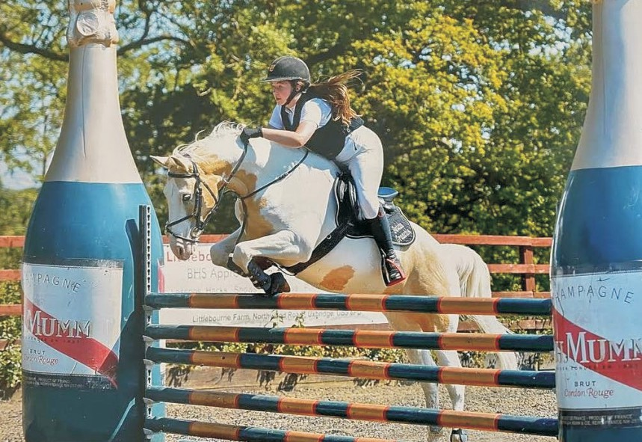
Littlebourne would like to thank Paynes Metal Recycling and the Payne family for sponsoring this show

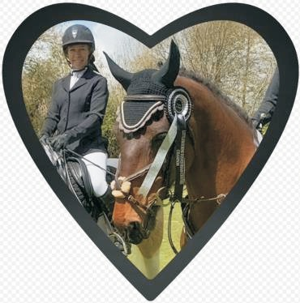
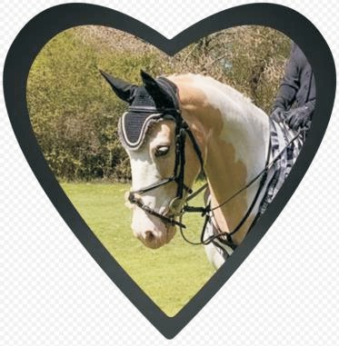

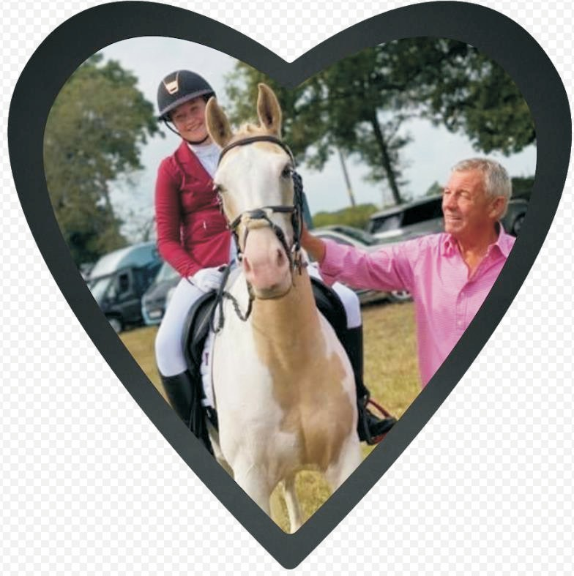

LITTLEBOURNE EQUESTRIAN CENTRE
Northwood Road, Harefield, Middlesex UB9 6PU Tel: 01895 824350
Website: www.littlebournefarm.co.uk
RIDING LESSONS (FOR ALL ABILITIES)
JUMPING LESSONS (ON SCHOOL HORSES OR YOUR OWN) HACKS - PONY PARTIES - DAY CAMPS
WE HAVE A FEW VACANCIES FOR FULL LIVERY. ALL TYPES CATERED FOR.
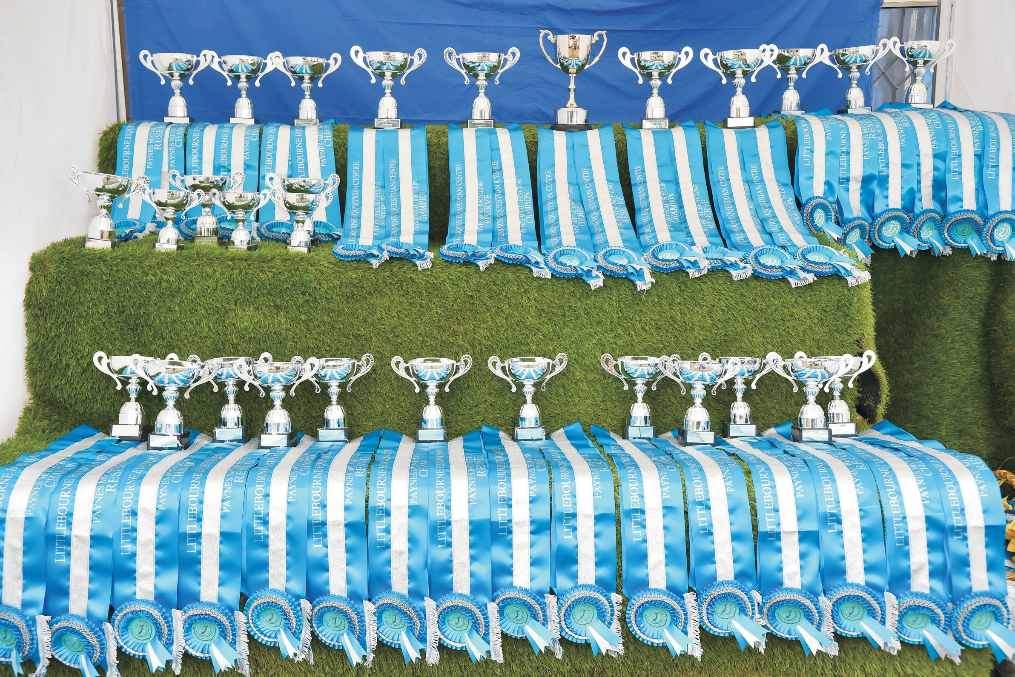
WE ARE OUTSIDE THE LOW EMISSION ZONE IF YOU FOLLOW THE. DIRECTIONS BELOW
From M25 J18. Take the A404 towards Rickmansworth.
At the next roundabout turn right still on the A404. Next roundabout continue on A404 (Not A412).
Next roundabout turn right still on A404.
Over Canal Bridge and turn right at next roundabout still on A404. Carry on up the hill and take the first right at a staggered crossroads.
{There is a pub on your left, Ye old Green Man.) Follow along this road, there is a sharp S bend and
Littlebourne is on your left. {The distance from the motorway is approx 5 miles)
Over 27 Perpetual Challenge Cups
All Classes Sponsored by Paynes Metal Recycling Company
& The Payne Family
Rosettes & Sashes in all Classes

RING TWO – Dressage & Ridden Showing
Commencing at 9:30am All Dressage Classes £15
PRE-ENTRIES ONLY. DRESSAGE ENTRIES CLOSE ON 1st May 2025

Class 11 Intro - Test 1 (2024)
Challenge cup and sash to the winner.

Class 12 Intro- Test 2 (2024)
Challenge cup and sash to the winner.

Class 13 Prelim Test 1 (2024)
Challenge cup and sash to the winner.

Commencing at 13:00 Approx - Pre-entries £12.50. Late / on the day entries £15.

Class 14 Littlebourne Riding School Best Turned Out – Not a qualifier
Challenge cup – Rossetts to all

Class 15 Best Turned Out Open
Challenge cup and sash to the winner.

Class 16 Family Horse
Open to horses 14.2hh and over, suitable to be ridden by all family members.
Challenge cup and sash to the winner.

Class 17 Best Rider
Mixed Junior and Senior.
Challenge cup and sash to the winner.

Class 18 Mountain & Moorland Ridden
Small & large breeds registered and unregistered. Challenge cup and sash to the winner.

Class 19 First Ridden
Riders up to 12 years. Ponies to be shown in snaffle bridles.
Challenge cup and sash to the winner.

Class 20 Pony Club Pony
14.2hh & under. Riders may be required to jump a small fence. Challenge cup and sash to the winner.

THE ORGANISERS ADVISE ALL CHILDREN TO WEAR BACK PROTECTORS

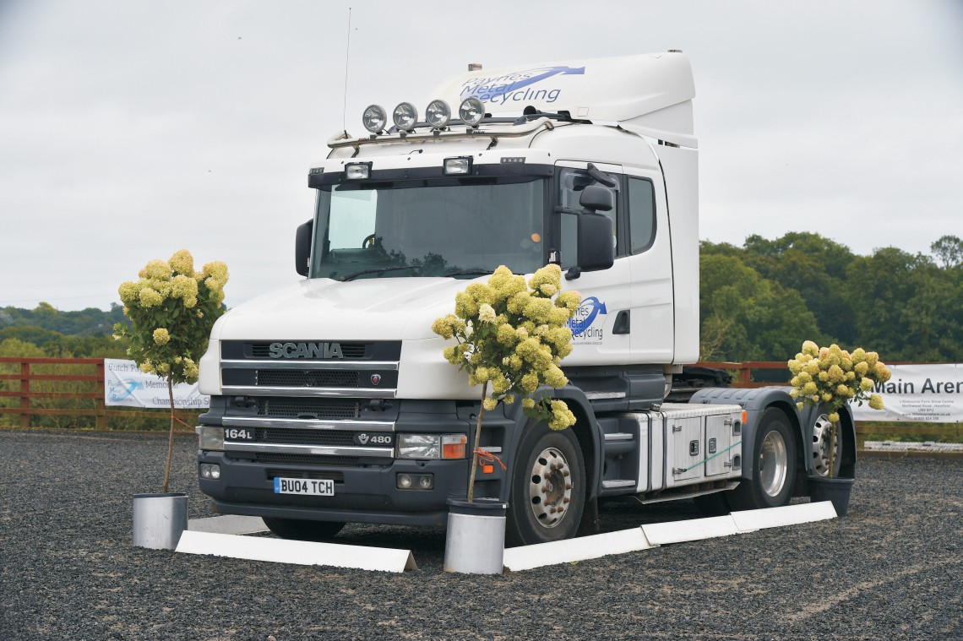
Trophies, Champion & Reserve Sashes
If you win a Challenge Cup you will be able to take it home for one year after paying a deposit of £25 per cup and provided proof of your
name and address. There are no exceptions to this rule.

